**Concept**

The game takes place in various levels in which the player aboard a ship, controlled by the 4 arrows on the keyboard, will have to collect 3 blue flags with the help of power ups before the opposing ships collect their 3 red flags.

The movement of the spacecraft is perceived with very little friction as if it were constantly crossing a sheet of ice.

The player will also have to pay attention to any traps placed on the floor of the level while avoiding the enemy ships, the latter divided into 2 groups, those that seek the flags and those that try to hinder him.

**Player movement**

The player can move by using the directional arrows on the keyboard, with the upward arrow he will be able to accelerate the vehicle, while with the downward arrow he will slow it down and possibly make it proceed in reverse, with the lateral arrows he will instead rotate the vehicle in the same direction making it curve if it is moving, if the player is stationary the spacecraft will proceed to rotate on itself clockwise/anti-clockwise based on the selected direction.

The player can only move forward and backward, the acceleration and the max speed is the same in both directions.

The direction of the player is displayed with a yellow line on the hover on the right side of the lower part of the UI, the length of the line represents the speed while the inclination represents the direction.

The movement of the player can be modified by power ups or traps, power ups can increase or decrease the max speed and allow the player to jump, traps can block the player movement for around 5 seconds or instantly change the player direction and launch the player with max speed for x seconds in that direction.

Player’s speed is displayed with a vertical yellow bar on the right part of the lower UI, player’s max speed without a power up is equivalent to the 75% of the full bar (15/20 lines), player’s max speed with the green traffic light is equivalent to 100% of the bar (20/20 lines) and the red traffic light is equivalent to about 33% of the bar (7/20 lines)

**Power ups**

Power ups are collectible items that add an effect, which can be either negative or positive, to the player.

They are displayed on the game map as floating spheres. The spheres are transparent and inside them there is a 3D model/Sprite which represents the effect applied to the player.

They are divided in 2 categories:

* Those that can be activated by pressing a-s-d in every moment if the player has obtained the corresponding sphere
* Those that get activated in the moment the player gets the corresponding sphere and has a limited time duration

Those belong to the first category:

* The spring, which can be activated with the A key, is represented as a yellow spring that rotates inside the floating sphere. When used, it allows the spacecraft to make a jump capable of overtaking medium-sized walls to make shortcuts or to get over enemies to avoid them, the power up of the spring cannot be used several times in a row while already in flight and the player will have to wait until he has landed to be able to use it again and raises the player by three height notches which are marked on the sidebar at the power up and can not surpass the maximum value of the bar itself

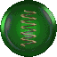

* The wall, which can be activated with the S key, is represented as a brick wall that rotates on its y axis inside the floating sphere, this allows, when used, to generate a wall (1,5x1 m) behind the player for about nine seconds to impact any enemy ships that are following it, the wall power up can be used several times in rapid succession as long as the player has multiple copies of it available (max 9), the duration timer of each wall is independent ( 9 seconds) and the duration of the last placed wall will always be shown in the sidebar on the screen of the last one generated by, additionally if the wall power up is use immediately after the spring one the wall will spawn mid air

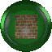

* Invisibility, which can be activated with the D key, is represented as a gray version of the ship that rotates inside the floating sphere, this allows the user to become invisible for about 9 seconds without being identified by enemy ships, during the 9 seconds of invisibility, a blue filter will be applied to the game layout, the invisibility power up can be used several times in a row as long as the player has multiple copies of it available, the latter's timer if used a second time or the more it will be reset and the duration in tracked on the sidebar

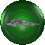

Those belong to the second category:

* The shield, represented as a red shield that rotates on its y axis inside the floating sphere, will make the player immune to traps and harmful tools for 20 seconds. If multiple copies of this power up are taken in succession the timer will be reset and the sidebar keep track of the duration, during the duration of the shield power up, all other power ups that are a malus for the player will be ineffective including the traps, if a player first gets a malus and briefly after picks up a shield, the malus effect will instantly end

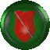

* The traffic light, divided into green and red; the green will increase the player's speed by 50% for 20 seconds, while the red will decrease it by 50% for 20 seconds, the 2 traffic lights do not equate each other but overwrite each other, so if the player takes both in rapid succession the applied effect will only be the last one acquired, both traffic light timers will be reset if the same type of traffic light is taken 2 times in rapid succession, both are represented as gray traffic lights with only the light of the respective type turned on inside of the floating sphere and the sidebar keep track of the timer

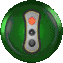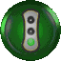

* Erase Map, represented as a stylized version of the lower part of the UI being struck by lightning (has a short animation of it impacting the mini-map part of the looping UI) inside the floating sphere, it will randomly erase parts of map explored by the player, which must be explored again to be reinstated.

Due to technical limitation now the “erase map” power up will cover the mini-map with an animated noise map sprite for a limited amount of time with a white screen, with low % of happening the player will be able to discover and easter egg where over the white noise png png covering the map the “driftveil toothless dancing meme” will be displayed

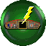

* The ?, represented as a ? with gray edges and a transparent interior (the sides, on the "side" however, are blue) which rotates inside the floating sphere, it will randomly give one of all the power ups of all the categories

All types of power ups regenerate with time and use by the player and at the start of the game they have the same % to generate (a certain type of power up will not be able to regenerate if the player has already collected a high quantity of them, the power ups that can be used with the keys are at a maximum of 9, the more power ups you have in a given category, the more likely it is that the game will generate missing categories, ex: I made a run by detaching as many power ups that can be used with the keys as possible and by the end of the game it tended to just give me traffic lights and “?”)

**Traps**

There are 3 traps in the game and they are represented as plates of 1x1 m on the ground over which the player passes, they also affect the ships controlled by the CPU:

* Ship lock, represented by a red plate with black edges and a spiral made up with a distortion effect in its center, it will forcibly hold the ship still for 5 seconds

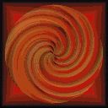

* remove flag, represented by a green plate with black edges with a red flag drawn on it covered by a red prohibition sign, it will remove a flag from the player's counter, replacing it randomly among the areas assigned to the spawn (I still have to carefully check which ones are , plausibly to be done once we have a complete version of the map) in the map, if the player has no flags collected it simply won't work

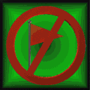

* The ship slides, represented by a green plate with black edges and 3 black overlapped arrow with red edges pointing in a direction, inside it has red lines that outline the shape of the arrow, it will force the player to turn in the direction towards which the box is pointing, if it is not facing the same direction as the arrow, but if the player passes over the aforementioned box while looking in the same direction he will receive a speed bonus equal to that of the green traffic light for 3 seconds, the "ship slides" plates always found in a minimum group of 2 side by side"

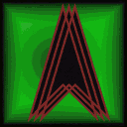

**Maps**

There are 3 maps in total for which each has an underlying theme: medieval, futuristic and sewers.

They are structured in a labyrinthine manner with a different mapping based on the 3 versions.

There are 16 levels available from which a player can start, after level 16 the CPU difficulty will be reset, but not the number of additional ships that the enemy team has; so once you reach the final level, the 26th, the CPU will again be at maximum difficulty but with a considerably higher number of ships.

The maps are repeated in a cyclical manner.

The map has a medieval setting and is structured like a labyrinth with walls depicting motifs relevant to the theme such as shields, swords, armor, chess symbols, various ornamentation

WALLS

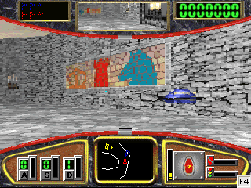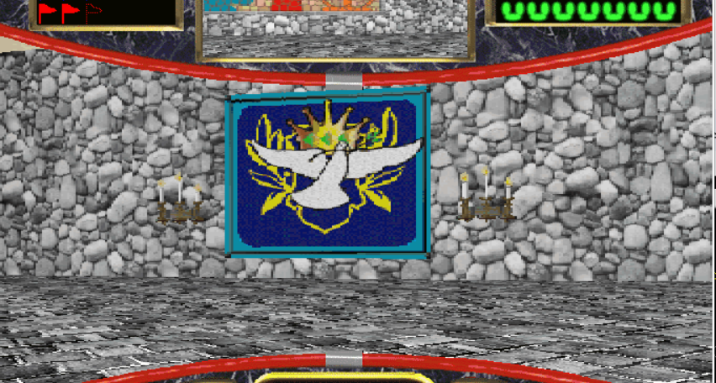

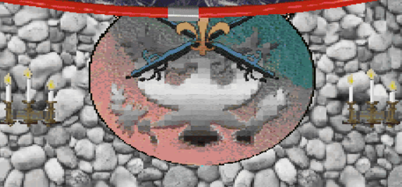

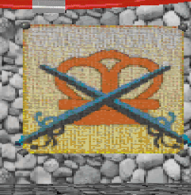

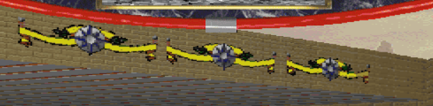

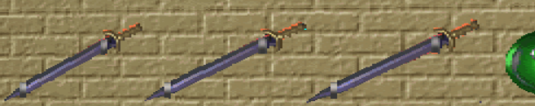

There are also railings, fireplaces and candelabras and wooden doors all on 2D pre-rendered surfaces

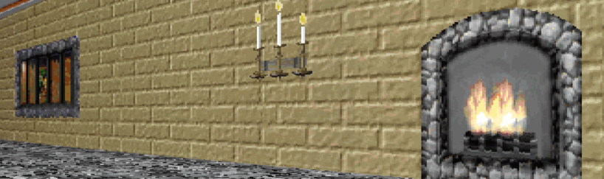

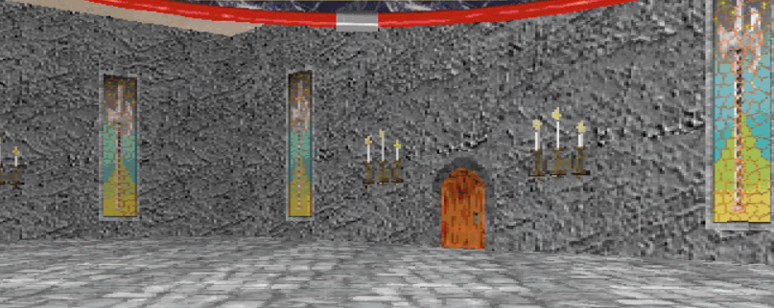

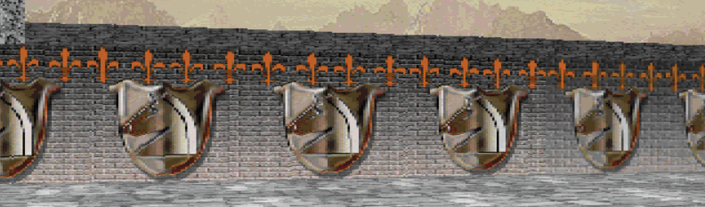

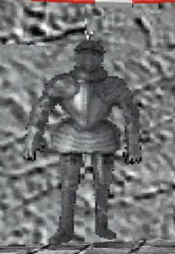

FLOORS AND RAMPS

They use basic 2D wall textures, the former are dotted with power ups and traps, the latter have multiple levels of steps generally in a rather standard shape with ornamental motifs on the front surface always of a medieval type at the upper levels



a generic wood texture instead for the first levels on both the front and side surfaces

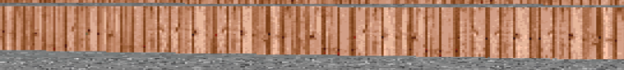

There are two ramps in the map that can be used as arena-style fps short-cuts

ENCOUNTERS AND MOVEMENT

Movement around the map occurs fluidly with barriers, encounters (attack hover, opposing team's ships, power ups, etc.), traps and flags to collect very clearly visible even from a good distance, the player never finds himself disoriented as the graphic elements of the various components of the game are clear and distinguishable. The player therefore has control over the map at every moment of the game, also aided by the minimap in the center which allows him to always orient himself in search of power ups and flags.

The ships of the opposing team move around the map according to reconnaissance patrol patterns in any game area in search of flags to collect which can spawn randomly across the map several times, while the attack hovers move circularly around the map, tending to avoid the outermost areas except the central areas of the map at the top and bottom. They can also spawn in the center of the map.

POWER UPS

As already written, they are of two types, namely those that can be activated by pressing the ASD keys and therefore collectible and then used at the player's discretion and those that are triggered instantly when they are collected. The sprites inside them are clearly visible 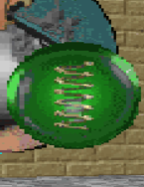

and clear on an iconographic level and therefore allow you to choose the ones that best suit your case, however, since they too are mobile throughout the map it can happen (especially when coming across the various spiral traps and slides) that take them by chance.

In the case of the power up erase map which previously covered part of the mini map, due to technical limitations, it was decided for this remake to appear, with a certain percentage of occurrence, a "driftveil toothless dancing meme" easter egg which it will cover the mini map in fact



TRAPS

The traps are scattered along the ground, easily distinguishable by the player even if in 2d and are of 3 types based on the motif represented in them:

* a concentric yellow spiral on a red background in the case of the ship lock
* a red prohibition sign on a green background in the case of the remove flag
* a black arrow on a green background pointing in the direction in which it will act on the player's movement

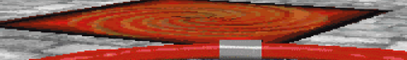

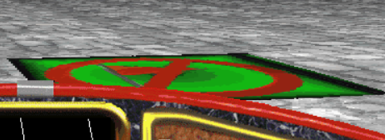

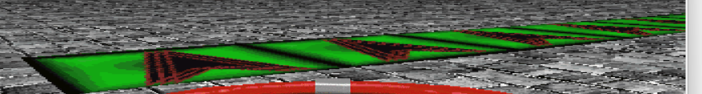

**MiniMap**

The mini map is displayed on a black screen in the center of the lower UI according to a bird's eye view with white lines to describe walls or ramps. It moves clockwise or anticlockwise in accordance with the directional inputs given by the player, allowing him to know exactly where he is at all times as well as keeping all nearby game elements under control.

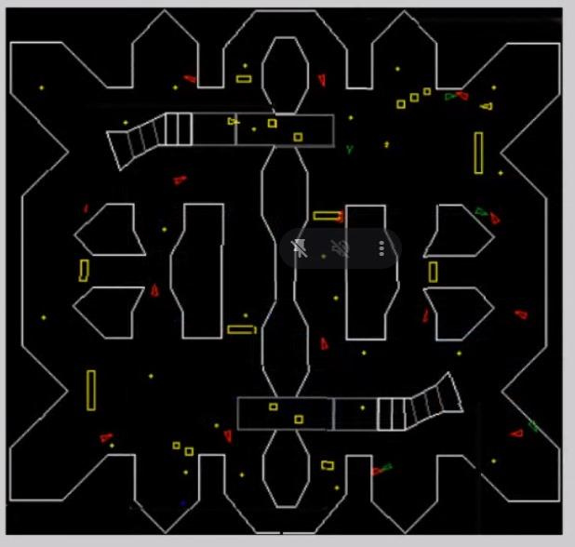

IN DETAIL

Ship: The ship appears on the mini map as a small red triangle that moves throughout the environment

Enemies: the enemies (the ships that collect flags also opponent team managed by the AI ​​and the attack hover) are also represented on the mini map as small triangles, blue in the case of the opposing team's ships, green in the case of the attack hover

Flags: they are represented by dots that light up intermittently in the corresponding color of the team (opponent blue, player's red)

Power ups: they are represented in the form of small yellow dots

Traps: are represented on the minimap as yellow tetrahedral shapes

**Enemies**

There are 2 types of enemies: the ships that collect the flags which follows a recognitive patrol searching for the flag in almost every area that it comes across even multiple times, and the attack hover, which are instead searching for the player, they go around the map in a circular way and never enter the external zones except for the middle and bigger ones in the top middle and the bottom middle the only other exception it’s for when the spawn in them, sometimes they go in the center of the map too.

The attack hover has the purpose to attack the player and disturb him in his actions by physically hitting him.

Here’s a mapped version of an attack hover and research hover path during a game

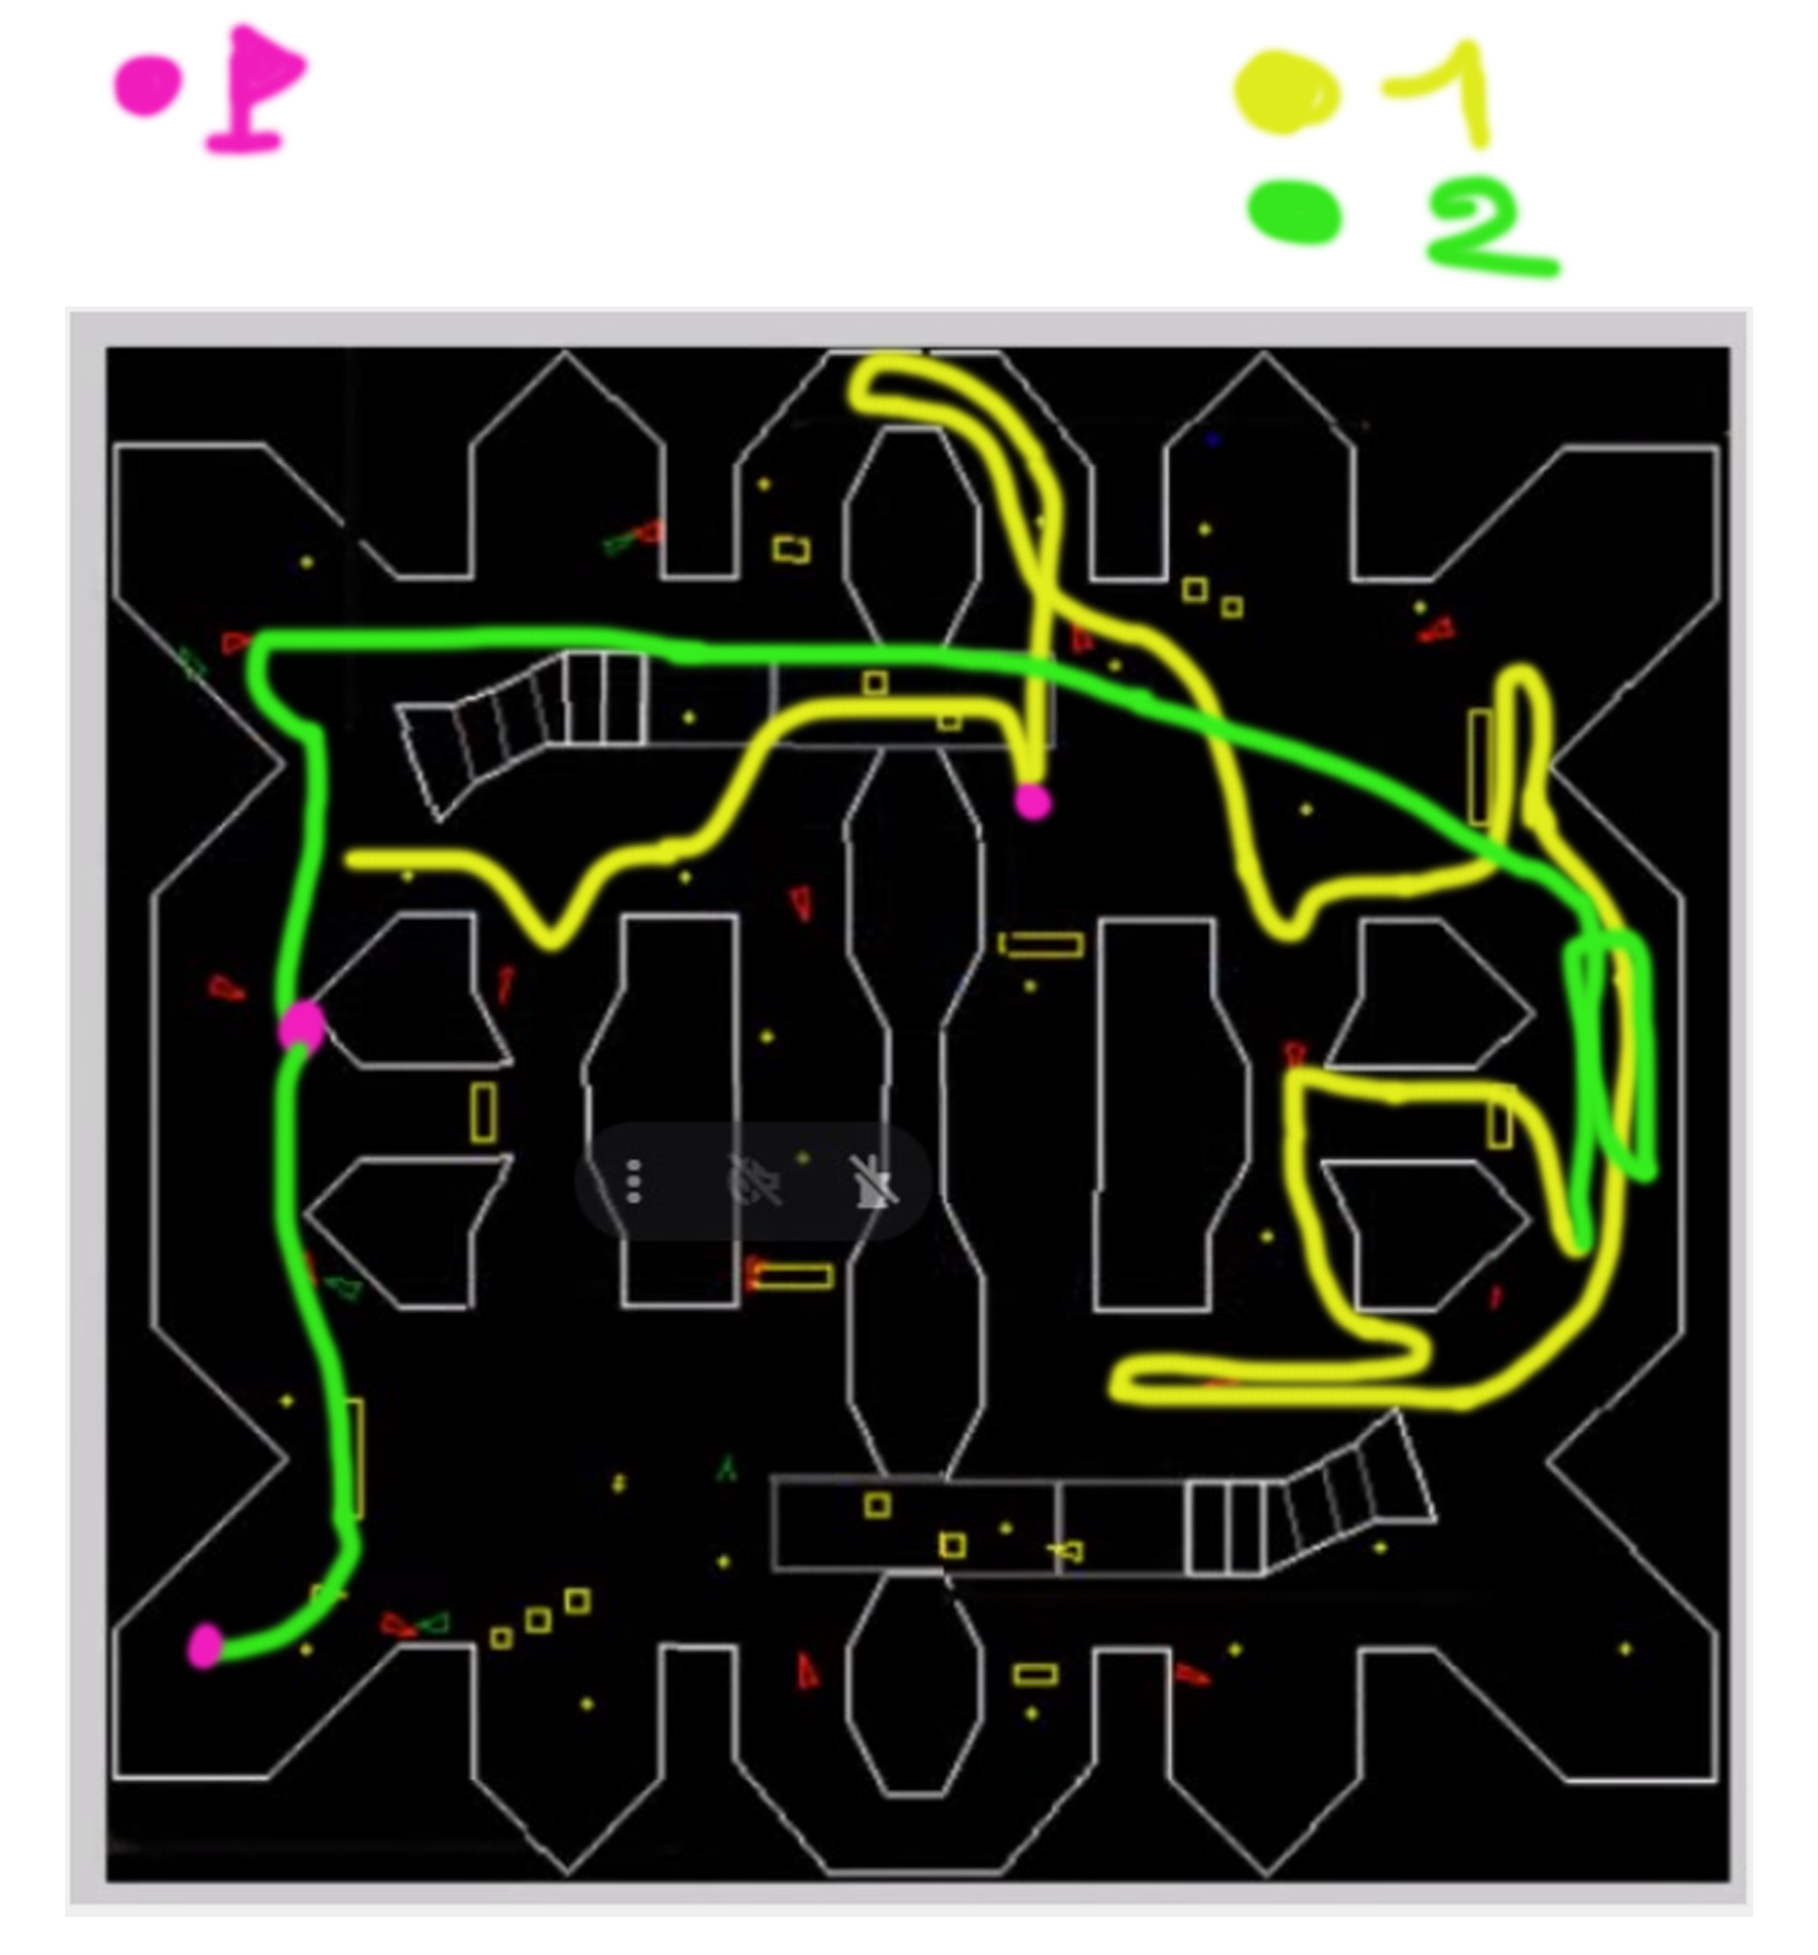

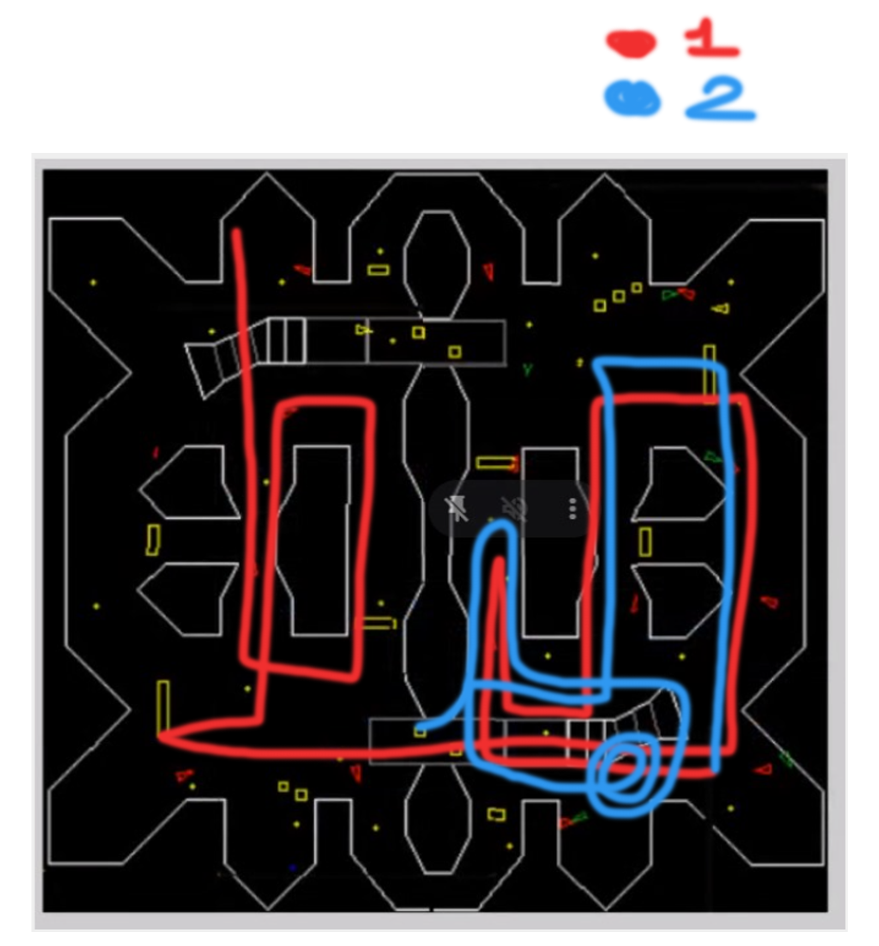

(the red and blue/ yellow and green lines represent the same hover, the color difference it was made only to understand the path since the hovers went multiple times in the same locations)

**Ui**

The ui is divided into 2, the upper and lower parts which in turn are divided into 3:

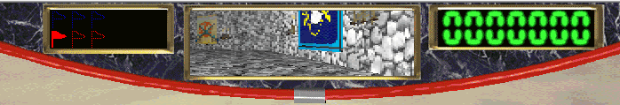

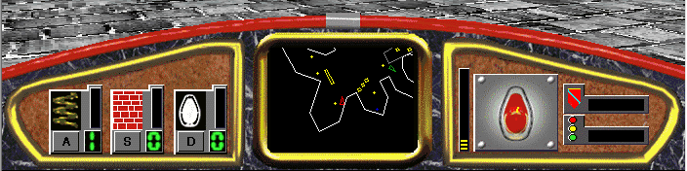

The 2 parts of the ui are visualized in 2 dark quartz curved backgrounds with red edges and a gray line in the middle.

* The upper part presents on the left the counter of flags that both the player and the enemies collect, initially represented with the dotted border of the team color when collected they will then be displayed in full color; it is represented as a black rectangular space with golden edges.

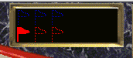

* The central part at the top represents the rear-view mirror of the spacecraft which will show the back of the latter allowing the player to also view the environment behind him, the mirror is rectangular and has the same edges of the flag part of the ui

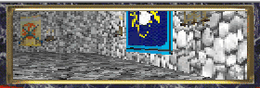

* At the top right, however, the player's current points counter is displayed, every time he collects a flag the score will increase by 1000, once all 3 have been collected the bonus score assigned will be 2500 for each flag that the enemies still have to collect (2500, 5000, 7500). It’s displayed as a rectangular black space with the same golden edges as before, in it there are 7 green zeros which will eventually changed into the player score

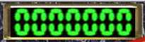

* The lower part on the left represents the various accumulable power ups that the player has assigned to the a-s-d keys (maximum value 9, if exceeded trivially the counter does not update).

It’s visualized as a semi-triangular shape with golden edges (more yellow than the one on the upper side) with a brown background, while every power up is displayed in some gray boxes one after the other with respectively has: the letter to which the power up is assigned, a counter bar that lists for how much the power up will last after it has been used and a black counter with green numbers representing how many copies of that power up the player has at the moment.

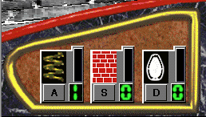

* The bottom center part represents the stylized map seen from above in which the player moves. The mini-map itself is in a rectangular space with the same golden edges as before and a black background on which the various maps and items are visualized.

On the mini-map, enemies will be represented by hollow triangles green blue or yellow based on their role (watch the enemies section), objects represented by yellow dots, flags represented by dots in the color of the team and traps represented by hollow yellow squares or rectangles based on size, finally the player is always represented by a red triangle.

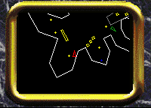

* At the bottom right, however, the direction and speed of the player and of the power ups that instantly activates are shown. this part of the ui is visualized in the same triangular shape with golden edges of the left side of the ui but flipped, the speed of the player is represented in a black bar with yellow notches up to 20, the player direction is shown as a gray square representing a panel with 4 dots representing some bolts to maintain it attached to the deck of the ship, on top of it a top view of a stylized version of the hover is shown, to actually indicate the direction a yellow line extend out of the center of the hover in the direction of which it’s going, it’s length is based on the speed of the player. (the direction of the yellow line considers the actual direction and momentum of the hover, so if the player is trying to go to the left but it has too much momentum, as the hover slides the yellow line will extend itself to the right even if the player is turning to the left).

The 2 time based power ups are showed in two horizontal black bars made up of 20 notches that will vanish as time passes (1 per second) the color of the notches is based on the power up, if it’s the shield it will be yellow, if it’s the traffic light it will be even green or red base on which power up the player gets. both of the bars have dark gray background and on the left the symbol of the corresponding power up.  
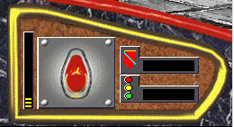

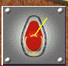

(the directional yellow line as the player is trying to turn to the left while it has already too momentum)

**Da aggiungere**

* Movimento nemici
* Suoni
* Rapporti schermi

Ricordate:

**SE NON VIENE SCRITTO NON VA FATTO**

**cit un programmatore**